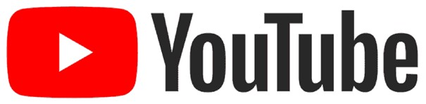

Product Dissection for YouTube - (Research Work)

Company Overview:

YouTube is an American [online](https://en.wikipedia.org/wiki/Online_video_platform) [creative](https://en.wikipedia.org/wiki/Online_video_platform) [video](https://en.wikipedia.org/wiki/Online_video_platform) [sharing](https://en.wikipedia.org/wiki/Online_video_platform) and [social](https://en.wikipedia.org/wiki/Social_media) [media](https://en.wikipedia.org/wiki/Social_media) platform headquartered in [San](https://en.wikipedia.org/wiki/San_Bruno,_California) [Bruno,](https://en.wikipedia.org/wiki/San_Bruno,_California) [California](https://en.wikipedia.org/wiki/San_Bruno,_California), [United](https://en.wikipedia.org/wiki/United_States) [States](https://en.wikipedia.org/wiki/United_States). Accessible worldwide, it was launched on February 14, 2005, by [Steve](https://en.wikipedia.org/wiki/Steve_Chen) [Chen](https://en.wikipedia.org/wiki/Steve_Chen), [Chad](https://en.wikipedia.org/wiki/Chad_Hurley) [Hurley](https://en.wikipedia.org/wiki/Chad_Hurley), and [Jawed](https://en.wikipedia.org/wiki/Jawed_Karim) [Karim](https://en.wikipedia.org/wiki/Jawed_Karim). It is owned by [Google](https://en.wikipedia.org/wiki/Google) and is the [second most](https://en.wikipedia.org/wiki/List_of_most_visited_websites) [visited](https://en.wikipedia.org/wiki/List_of_most_visited_websites) website, after [Google](https://en.wikipedia.org/wiki/Google_Search) [Search](https://en.wikipedia.org/wiki/Google_Search). YouTube has more than 2.8 billion monthly users as of 2023.

In October 2006, YouTube was bought by Google for $1.65 billion. Google's ownership of YouTube expanded the site's business model, expanding from generating revenue from advertisements alone to offering paid content such as movies and exclusive content produced by YouTube. It also offers [YouTube](https://en.wikipedia.org/wiki/YouTube_Premium) [Premium](https://en.wikipedia.org/wiki/YouTube_Premium), a paid subscription option for watching content without ads. YouTube also approved creators to participate in [Google's](https://en.wikipedia.org/wiki/Google_AdSense) [AdSense](https://en.wikipedia.org/wiki/Google_AdSense) program, which seeks to generate more revenue for both parties. YouTube Shorts is a way for anyone to connect with a new audience using just a smartphone and the Shorts camera in the YouTube app. YouTube’s Shorts creation tools makes it easy to create short-form videos that are up to 60 seconds long with our multi-segment camera.

Product Dissection and Real-World Problems Solved by YouTube:

YouTube, a global tech giant, has effectively managed to solve real life problems and has opened a new scope of earning. With special emphasis on video sharing, YouTube enables YouTubers to upload fruitful and effective videos that circulate the knowledge sharing process. It provides a very simple UI interface that is easy to understand and access. Content creators use CMS for uploading videos and regulating monetization.

A conclusive statement marks the success of YouTube in accomplishing the objective of solving real world problems. With time, YouTube has been evolving and adding new features to its UI making customer engagement more intuitive.

YouTube has significantly managed to and is continuously addressing the real world problems on a very larger scale:

# @ **Problem 1: Access to information and Education**

Real Life Challenge: Although there are many websites that provide paid video content, it is equally important that the content is easily accessible and available for free to the users. More the content based websites, the more the users are puzzled to decide which one to refer and follow and which one not to.

YouTube’s Solution: YouTube has emerged as an ocean to the educational content where anyone can upload interactive and productive educational videos may it be long or short, users can view them as per their convenience and that too for free of cost. There are multiple channels that learners can refer to in order to understand the concepts and clear their doubts.

# **@ Problem 2: Entertainment and Creativity**

Real Life Challenge: There is no dedicated platform where artists could present themselves and get applauded or even paid. Most of the artists remain unnoticed due to the limited stage.

YouTube’s Solution: YouTube provides an open platform to the dancers, artists, singers, comedians, gamers and many more to showcase their talent to the global homogenous audience. They even opt to do it as full time since they get paid for it, they get noticed by the organizers who call them up for the shows.

# **@ Problem 3: Global Outreach**

Real Life Challenge: Many websites do provide the platform for people who want to share their viewpoints on a particular topic but are not organized in a well manner and synchronous way.

YouTube’s Solution: YouTube is the best platform to share opinions on global causes and get the targeted audience with the same mindset to connect with. Moreover, allowing to share campaigns, stories, messages etc. irrespective of international barriers.

# **@ Problem 4: Career Opportunities**

Real Life Challenge: There are a lot of talented people all around the world who want to showcase their skills, who want a decent income generating party line but they struggle to find the right tenet.

YouTube’s Solution: YouTube undoubtedly has turned out to be an office for many tutors who share their knowledge and get paid for the same either through subscription, merchandise, sales or ad-sense and moreover YouTube provides a pool of free resources for the students to opt.

# **@ Problem 5: Cultural Exchange**

Real Life Challenge: The best approach to exchange, explore and know about each other’s culture, heritage and tradition is to meet and gather, but when there are international boundaries parting them, then it becomes difficult to do so.

YouTube’s Solution: YouTube is the best place to explore more about not just your own culture and tradition but of others as well. It promotes cross-culture understanding and sharing without being physically present.

# **@ Problem 6: Health and Wellness**

Real Life Challenge: The day today's life has become so complex and tedious that people sacrifice their mental as well as physical health. They refrain from consulting doctors more often and fall into deep anxiousness and anxiety.

YouTube’s Solution: YouTube provides engaging health related videos like on mental and physical health that promotes mentalists and psychologists to share their experience, facing the challenges of life and getting out of deep anxiety and anxiousness, living a happy life.

# **@ Problem 7: Inspiration and Motivation**

Real Life Challenge: It sometimes is not feasible for everyone to get some time out of their busy life and go out to listen to some motivational speakers that could bring a drastic change in their life, if not at least give them a sense of how to face the challenges of life. For motivational speakers, organizing such sessions at regular intervals is quite challenging as it requires a lot of preparation and setup.

YouTube’s Solution: YouTube allows motivational speakers from around the world to upload motivational videos which positively impacts the thinking of viewers which could probably help them to attain their goals and the targeted audience also need not to go anywhere, they can simply sit back and watch it.

Top Features of YouTube:

YouTube has been updating itself from time to time, some of the prominent features that YouTube offers are:

1. Video Hosting: YouTube is a well recognized digital platform that allows content creators to upload their videos, share them publicly or privately as per the audience of their choice.
2. Search and Discovery: YouTube is known for its deep pool of videos, it can be sorted based on duration, upload date, preference, type and many more. It has a highly flexible algorithm that suggests videos based on history.
3. Subscription: This is one of the key features of YouTube through which it allows monetization. Users can subscribe to their favorite channels and get a notification whenever that channel creator uploads a video.
4. Monetization: There are various ways on YouTube through which content creators can earn money like including ads, paid partnership, merchandise etc.
5. Live Streaming: One of the best use cases where YouTube allows content creators to interact with their audience in real time. This feature is mainly utilized for gaming, live doubt sessions etc.
6. YouTube Premium: Earning on YouTube comes through ads but many viewers don’t like to watch too many ads, so for them YouTube offers a premium subscription wherein viewers can pay a monthly subscription fee and get rid of unwanted ads.
7. YouTube TV: These days people are so occupied in their life that they don’t get much time to watch TV. So, to cater to this, YouTube introduced YouTube TV on the go, wherein viewers can watch live TV channels just like traditional TV channels.
8. Community Features: Another feature that allows content creators to interact with their audience through community posts, live chat, and live streams.
9. Customization: One of the extensive features of YouTube that propels users to create their playlist, organize subscription and set notification alerts.
10. YouTube Shorts: A newly added feature of YouTube where short form videos could be uploaded just like Tik Tok and Reels.
11. YouTube Kids: In order to protect kids from viewing irrelevant videos, YouTube added a separate app for kids, which has a built-in parental control feature.
12. Copyright Protection: Video uploaded over the internet can be misused, to cater this problem YouTube added a Copyright feature which protects videos uploaded from unauthorized access.
13. Playback Quality: Videos uploaded on YouTube can be viewed in various picture formats like Auto, 144p, 240p, 4K, 8K etc.
14. Video Editing Tools: For content creators YouTube provides an inbuilt video editing feature, that helps in making some basic edits.
15. VR and 360 degree Videos: YouTube provides an immense and splendid video experience by enabling virtual reality and 360 degree videos.

Schema Description:

The schema for YouTube involves multiple entities that represent different aspects of the platform.

* 1. User Profile:

· User ID (Primary Key) - A unique identifier for each user/creator

· Username - Defined username/creator

· Email ID - Email ID of the user/creator

· Profile Picture - Profile picture uploaded by user/creator

· Subscription (List of Channels) – List of defined channels

· Upload Videos (List of Video IDs) – List of video IDs uploaded

· Liked Videos (List of Video IDs) - List of video IDs liked · Playlists (List of Playlist IDs) - List of playlist IDs uploaded

* 1. Video:

· Video ID (Primary Key) - A unique identifier for each video

· Title – Title of the videos uploaded by user/creator

· Description - Description of the videos uploaded

· Duration – Duration of the videos uploaded

· Upload Date – Date of the videos uploaded

· Views Count – No.of views count on videos uploaded

· Likes Count - No.of likes count on videos uploaded

· Dislikes Count - No.of dislikes count on videos uploaded

· Thumbnail URL – Link to the thumbnail URL

· Privacy Settings (Public, Private, Unlisted) – Privacy setting adjusted

· Location (Optional) – Location of the videos uploaded from

· Comments (List of common IDs) – Comments by viewers on videos

· Tags (List of Keywords) – Tags imposed on the videos

· Creator (User ID of the uploader) – User ID of the uploader

· Video URL – Link to the videos URL

1. Channel:

· Channel ID (Primary Key) - A unique identifier for each channel

· Channel Name – Name of the proposed channel

· Description – Short description about the channel

· Subscribers Count – No.of viewers subscribe the channel

· Created Date – Date on which channel was created

· Channel Owner (User ID of the creator) – User ID of the uploader

· Videos (List of Video IDs) – List of the video IDs uploaded by uploader

· Playlists (List of Playlist IDs) – List of the playlist IDs by uploader

· Featured Channels (List of other channel IDs) – Subsidiary IDs list

· Profile Image URL – Image of the channel page

1. Playlist:

· Playlist ID (Primary Key) - A unique identifier for each playlist

· Playlist Title – Name defined to the playlist

· Description – Short description defining playlist

· Created Date – Date on which playlist was created

· Videos (List of video IDs) – List of video IDs

· Creator (User ID of the playlist owner) - User ID of the playlist owner

1. Comment:

· Comment ID (Primary Key) - A unique identifier for each comment made

· Comment Text – Text of the comment made by each viewer

· Commenter (User ID of the commenter) – User ID of the commenter

· Comment Date – Date on which respective comment was made

· Likes Count – No.of likes hit count

· Replies (List of comment IDs for replies) - List of comment IDs for replies

1. Subscription:

· Subscription ID (Primary Key) - A unique identifier for each playlist

· Subscriber (User ID of the subscriber) - User ID of the subscriber

· Channel (Channel ID of the subscribed channel) – Channel subscribed

· Subscription Date – Date of subscription

1. Category:

· Category ID (Primary Key) - A unique identifier for each playlist

· Category Name – Name of defined category

· Description – Description about the defined category

1. Playlist Video

· Playlist Video ID (Primary Key) - A unique identifier for each playlist

· Playlist (Playlist ID) - Playlist ID

· Video (Video ID) - Video ID

· Position (Order of videos within the playlist) – Arrangement of videos

Imminent Utilities/Attributes:

1. User Profile - User ID, Username, Email ID, Profile Picture, Subscription, Upload, Videos, Liked Videos, Playlists, Video, Channel, Playlist, Subscription, Comment.
2. Video - Video ID, Title, Description, Duration, Upload Date, Views Count, Likes Count, Dislikes Count, Thumbnail URL, Privacy Settings, Location, Comments, Tag, Creator, Video URL.
3. Channel - Channel ID, Channel Name, Description, Subscribers Count, Created Date, Channel Owner, Videos, Playlists, Featured Channels, Profile Image URL.
4. Playlist - Playlist ID, Playlist Title, Description, Created Date, Videos, Creator.
5. Comment - Comment ID, Comment Text, Commenter, Comment Date, Likes Count.
6. Subscription - Subscription ID, Subscriber, Channel, Subscription Date

Relationships:

1. User uploads Video (One-to-Many): Each user can upload multiple videos, but each video is uploaded by one user.
2. User creates Channel (One-to-One): Each user can have one channel.
3. Users can subscribe to Channel (Many-to-Many): Many users can subscribe to many channels, so this would require a junction table to represent subscriptions.
4. Video can be in Playlist (Many-to-Many): Many videos can be in many playlists, so a junction table is needed to represent video-playlist relationships.
5. Users can comment on Video (One-to-Many): Each user can leave multiple comments on various videos.
6. Video can have Comments (One-to-Many): Each video can have multiple comments.

ER Diagram:

We have an ER diagram that reflects the relationships and attributes of the entities within the YouTube schema. This ER diagram will showcase the pictorial relationship between schemas within the structure. By employing this diagram, you'll gain a clearer grasp of the intricate interactions and connections that define the platform's dynamics.

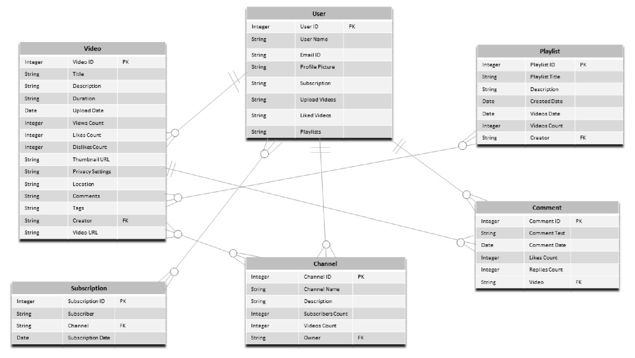

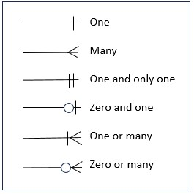

Conclusion:

This case study gives an insight of YouTube design schema and Entity Relationship Diagram. YouTube undoubtedly has emerged as one the biggest tech giants around the world. The key features of YouTube like Video hosting, monetization, live streaming, career opportunity, copyright protection, kids safety etc. makes it stand apart from others and gives it an edge over other such applications available over the internet. Through this schema we managed to gain an insight of how YouTube schema looks and functions, how YouTube has possessed to change the lives of many.